**Restaurant Recommendation System Using CF**

**Team Uncertainty :- Suraj Kumar Mondal, Saurabh Shetty, Gritika Pardeshi and Nazim Saifi**

**Model**

1. **Recommendation System using randomly initialized latent vectors :** Here we are randomly initializing the latent features and train them by stochastic gradient descent.
2. **Recommendation System using Restaurant features :** Here we used a static restaurant feature and use gradient descent to create user embeddings.
3. **Using PCA on restaurant features** : The restaurants have 141 features which would create a large sparse embedding, hence we will reduce it by using PCA on the features

**Motivation and About the Project**

Artificial intelligent systems are usually perceived as black boxes, where the input and output are easily understood, but the processes that return the output consider too many variables and are too complex to be condensed into a simple equation. As such, while mechanisms like collaborative filtering are very effective in proposing a recommendation, they’re poor in clarifying why certain items are being suggested, beyond declaring generic formulas such as ‘users who bought item A also bought item B’. Evaluating RS only through accuracy metrics and runtime computation complexity is not enoughto get the full picture. User satisfaction, trust and result diversity has gainedincreasing weight when evaluatingthese systems.

**Conclusion and Future Work**

According to our RMSE score, Recommendation System using randomly initialized latent vectors looks performing better with RMSE equal to 1.38 followed by Recommendation System using Restaurant features and Using PCA on restaurant features with RMSE 2.74 and 3.51 respectively.

**For Future work :** We can make a Semantically Aware Explainable Recommender System using Asymmetric Matrix Factorization: The semantic data can be a source of knowledge for the system about both users and items, which can then be used to create meaningful explanations from the relations between both. If a semantic feature belongs to an item; in our case, a restaurant category such as serving vegetarian food or so like young, male are semantic features of the word boy which can be converted to binary. So, this way we can generate more features, or recommend specific restaurants to users.

**Results**

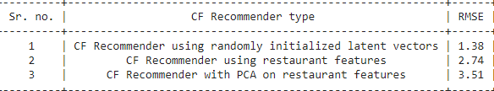

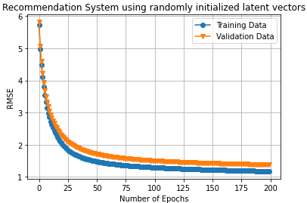

**References**

* Recommender System With

Explanations by Frederico Portugal Pinho Rocha.

**Data and Labels**

The Yelp dataset is a subset of businesses, reviews, and user data. This dataset contains 150,346 businesses, 6,990,280 reviews and 200,100 pictures of 11 metropolitan areas.

in which it has 908,915 tips by 1,987,897 users, Over 1.2 million business attributes like hours, parking, availability, and Aggregated check-ins over time for each of the 131,930 businesses